Textile Wholesale Catalog Link – Requirement C Feature Document


·
Oct 28, 2026
Prince

Overview
We are building a SaaS platform (working name: CatalogLink) that gives every Surat textile wholesaler one live catalog link, fed from their own Google Sheet and Google Drive, where their customers browse, add to cart and place orders.

Problem today
- Wholesalers and resellers in Surat share every new design and stock update on WhatsApp, one photo and one message at a time.
- The same photos, price, fabric and set details go to every customer again and again.
- Customers reply with screenshots; the wholesaler rebuilds the order by hand and often sells stock that is already gone.

Solution
- Super Admin adds a client (wholesaler); the system auto-generates a unique catalog link for that client.
- The client connects a Google Sheet. Every product row in the sheet (with image links from Google Drive) shows up on the link automatically.
- The client can also create extra links manually for specific customers or customer groups.
- Customers open the link on their phone (no app, no login needed to browse), add products to cart and place the order.
- The client receives the order on their dashboard and on WhatsApp, and manages quantity (stock) in the same Google Sheet.
Reference: Showkase solves a similar problem for corporate gifting. Our product is the same idea adapted for textile wholesale (sets, colours, MOQ, catalog-wise selling) with Google Sheet as the main data source.

Goals and success metrics
The product succeeds when a wholesaler stops forwarding photos on WhatsApp and sends one link instead.

Goal | How we measure it
Client goes live fast | Sheet connected and first link shared within 15 minutes of signup
No repeated photo sharing | New products appear on the link only by adding a row in the sheet
Orders come in structured | Orders placed on the link, not typed in WhatsApp chat
Correct stock | Out-of-stock products are hidden or marked automatically from the sheet qty
Easy for customers | Customer can place an order without installing an app

User roles
The platform has three roles, plus optional staff logins under a client.

Role | Who | Main work | Access
Super Admin | Our company (platform owner) | Add/manage clients, plans, subscription, support | Full platform
Client | Textile wholesaler / reseller in Surat | Connect sheet, manage products, links, customers, orders | Own business data only
Client Staff (optional) | Client's sales / order team | Handle orders and customers | Role-based, set by client
Customer | Retailer, reseller or shop owner buying from the client | Browse catalog link, add to cart, place order, track order | Only the links shared with them

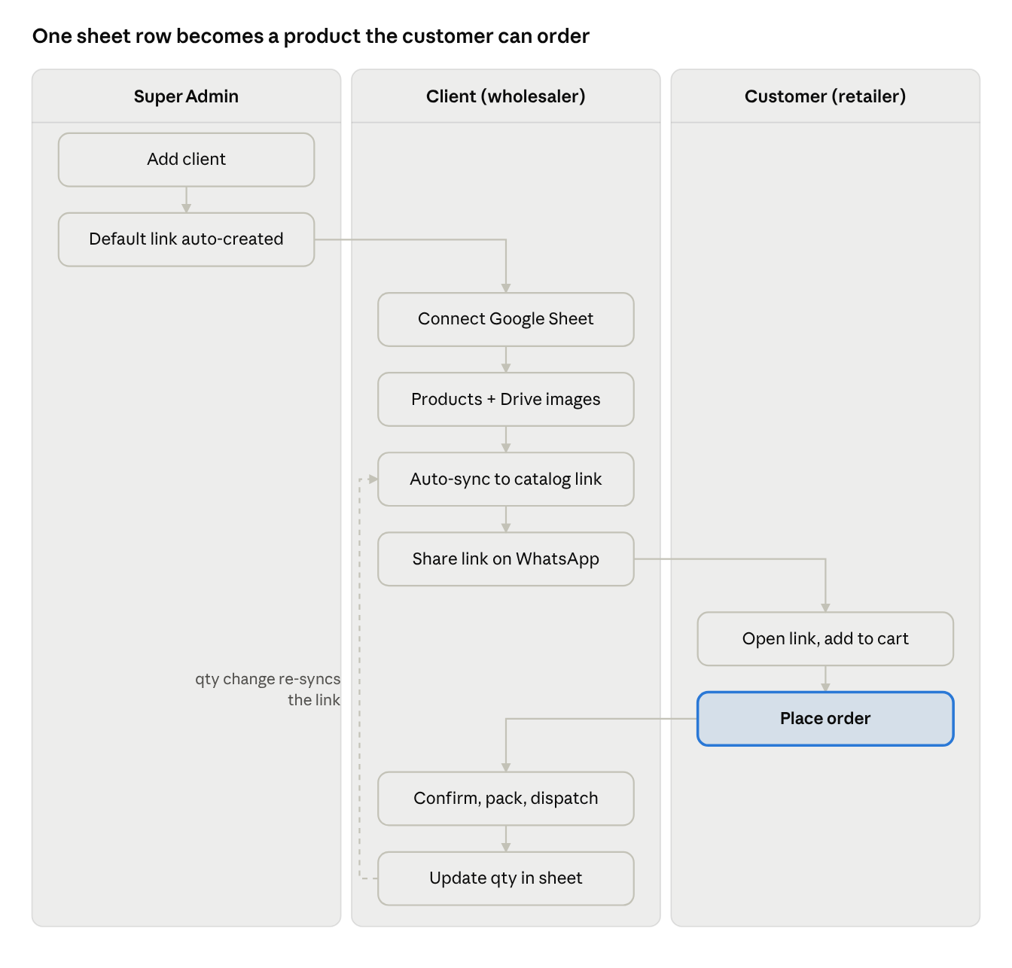
End-to-end user filow

end-to-end flow · 3 roles, 10 steps
Super Admin sets up the client once; after that the client only edits the sheet, and every qty change flows back to the customer link on the next sync.

Super Admin panel fieatures
Super Admin controls who uses the platform; adding a client auto-creates that client's default catalog link.

Client management
    - Add client: business name, owner name, mobile (WhatsApp), email, GST number (optional), city, address, logo.
    - On save, the system auto-generates a unique default catalog link, e.g.
.
cataloglink.in/c/shree-krishna-textiles
    - Edit, activate, deactivate or delete a client. A deactivated client's links show a "catalog not available" page.
    - Send login credentials to the client on WhatsApp / email.
    - Login as client (impersonate) for support.

Plans and subscription
    - Create plans with limits: number of products, number of custom links, staff logins, orders per month.
    - Assign plan, set start/expiry date, free trial days.
    - Payment record (manual entry or payment gateway such as Razorpay in Phase 2).
    - Auto-reminder before plan expiry.

Monitoring and reports
    - Dashboard: total clients, active clients, links created, orders placed today / this month.
    - Client-wise usage: products synced, last sheet sync time, sync errors.
    - Sync error log so support can see why a client's sheet failed.

Platform settings
    - Default sheet template (downloadable) for new clients.
    - WhatsApp / SMS / email notification templates.
    - Domain and branding settings.

Client panel fieatures
The client (wholesaler) runs the whole business from a mobile-friendly web dashboard; product data stays in their Google Sheet.

Onboarding
    - Login with mobile OTP or email + password.
    - Business profile: logo, banner, business name, WhatsApp number, address, GST, payment details (UPI / bank) shown to customers.
    - Step-by-step setup: download sheet template → connect Google account → select sheet → sync → share link.

Google Sheet connection
    - Connect Google account (OAuth) and pick a sheet, or paste a sheet link shared with our service account.
    - Map columns if the client's sheet uses different headers.
    - Sync now button + auto-sync every few minutes.
    - Sync status: last synced time, rows added / updated, rows with errors (missing price, broken image link).

Product view (read from sheet)
    - Product list with search and filter by category, catalog, stock status.
    - Preview how each product looks on the customer link.
    - Hide / show a product on the link without deleting the sheet row (Active column).

Catalog link management
    - Default link auto-created by Super Admin (shows all active products).
    - Create manual links for a specific customer or group: choose products by category, catalog name or individual selection.
    - Per-link settings: link name, expiry date, show/hide price, customer-specific price (Phase 2), password / OTP protection, allow ordering on/off.
    - Copy link, share on WhatsApp in one tap, generate QR code.
    - Link analytics: opens, unique visitors, products viewed, add-to-carts, orders.

Customer management
    - Customer list auto-created from orders (name, shop name, mobile, city, GST).
    - Add customers manually and assign links to them.
    - Customer-wise order history.
    - Block a customer from ordering.

Order management
    - See section 9.

Staff logins (Phase 2)
    - Add staff with roles: order handler, viewer, admin.
- Google Sheet + Drive integration
One row in the sheet = one product on the link; images live in the client's Google Drive, so there is no image upload or storage on our side.

How it works
- Client downloads our sheet template (or uses their own sheet and maps columns).
- Client uploads product photos to a Google Drive folder and sets sharing to "Anyone with the link can view".
- Client pastes the image link(s) into the sheet row, or pastes one Drive folder link per product and the system picks all images in it.
- System syncs the sheet (auto every few minutes + "Sync now" button) and updates the catalog link.
- When an order is confirmed, the system can reduce qty in the sheet automatically (setting on/off, see section 10).

Suggested sheet columns

Column | Required | Example | Notes
Product Code / SKU | Yes | SK-1021 | Unique; used to match orders and stock
Product Name | Yes | Banarasi Silk Saree
Catalog Name | No | Rangoli Vol-3 | Groups designs into a catalog
Category | Yes | Saree / Kurti / Dress Material / Lehenga | Used for filters
Fabric | No | Pure Georgette
Colours / Variants | No | Red, Green, Blue | Comma separated
Sizes | No | M, L, XL, XXL | For kurti / readymade
Pieces per Set | No | 4 | Set-wise selling
Wholesale Price (₹) | Yes | 850 | Per piece or per set

Column | Required | Example | Notes
MRP (₹) | No | 1499
Price Type | No | Per piece / Per set
MOQ | No | 1 set | Minimum order qty
Available Qty | Yes | 120 | Managed by client
Image Links | Yes | Drive link(s) | Multiple links comma separated
Video Link | No | Drive / YouTube link
Description | No | Free text
GST % | No | 5
Active (Yes/No) | Yes | Yes | No = hidden from link
Tags | No | New Arrival, Wedding | Shows badges

Technical notes
  - Google Sheets API + Google Drive API; OAuth for client accounts.
  - Convert Drive share links into direct image URLs and cache thumbnails (CDN) for fast loading on mobile.
  - Validation on sync: skip rows missing SKU, price or image, and show the error row number to the client.
  - Respect Google API limits; queue syncs per client.

Customer catalog link
The link opens like a mini online store in any mobile browser, branded with the client's logo, with no app download.
- Branded header: client logo, business name, banner, WhatsApp / call button.
- Product listing: grid view with image, name, price, set info, "New" / "Out of stock" badges.
- Search and filters: by category, catalog name, fabric, price range, colour, new arrivals.
- Catalog view: open a full catalog (e.g. "Rangoli Vol-3") and see all its designs together.
- Product detail: image gallery with zoom, video, fabric, sizes, colours, set pieces, MOQ, price, available qty.
- Select variant: colour / size / full set; quantity with MOQ check and max = available stock.
- Share product: customer can forward a single product to WhatsApp.
- Wishlist / shortlist (Phase 2).
- Language: English + Hindi / Gujarati labels (Phase 2).
- Privacy options per link: price visible only after OTP login; password-protected link.
- Fast on low network: compressed thumbnails, lazy loading.

Cart, order and order management
Customers place a structured order on the link; the client confirms it on the dashboard and the customer tracks it on the same link.

Customer side
    - Add to cart with variant and qty; cart shows item total, GST (if set) and grand total.
    - Checkout: name, shop name, mobile (OTP verify), city, delivery address, GST number (optional), transport / courier preference, notes.
    - Payment mode as set by client: Pay later / credit, UPI QR, bank transfer details, online payment (Phase 2).
    - Order confirmation page + order details sent on WhatsApp.
    - "My orders" on the link (via mobile OTP) to see status.
    - Re-order a previous order in one tap (Phase 2).

Client side
    - New order alert on dashboard + WhatsApp / email.
    - Order list with filters: new, confirmed, packed, dispatched, delivered, cancelled.
    - Order detail: customer info, items, variants, qty, total, notes.
    - Actions: accept, edit qty (partial accept when stock is short), reject with reason, mark payment received.
    - Status update: confirmed → packed → dispatched (transport name, LR / AWB number)
→ delivered.
    - Download order as PDF / print packing slip; export orders to Excel.
    - Option to write every order into an Orders tab of the same Google Sheet.

Order statuses

Status | Who sets it | Customer sees
Placed | System | Order received
Confirmed | Client | Order confirmed
Partially confirmed | Client | Some items not available
Packed | Client | Being packed
Dispatched | Client | Shipped + transport / LR details
Delivered | Client | Delivered
Cancelled / Rejected | Client or customer | Cancelled with reason

Stock / quantity management
The Google Sheet's Available Qty column is the single source of truth for stock; the client edits it manually and the link follows.
- Qty 0 → product shows "Out of stock" (or is hidden, as per client setting).
- Low stock badge ("Only 5 left") below a threshold the client sets.
- Customer cannot add more than the available qty to cart.
- Stock check again at checkout, so two customers cannot buy the same last set.
- Auto-deduct setting (on/off): when the client confirms an order, the system reduces qty in the sheet; a cancelled order adds it back.
- If auto-deduct is off, the client updates qty in the sheet manually and the link shows it after the next sync.
- Variant-wise stock (per colour / size) in Phase 2 via extra columns.

Notifiications
WhatsApp is the main channel, because both clients and customers already live there.

Event | To client | To customer | Channel
New order placed | Yes | Order received | WhatsApp, email, dashboard
Order confirmed / partially confirmed | – | Yes | WhatsApp
Order dispatched (with LR / AWB) | – | Yes | WhatsApp
Order cancelled / rejected | Yes | Yes | WhatsApp
New products added to a link | – | Optional broadcast | WhatsApp (Phase 2)
Sheet sync failed | Yes | – | Dashboard, email
Plan expiring | Yes | – | WhatsApp, email

MVP can use click-to-WhatsApp (wa.me) messages; Phase 2 moves to the WhatsApp Business API for automatic messages.

Refierence: Showkase vs our product
Showkase is built for corporate gifting (quotes, logo mockups, gift boxes); we keep its core idea of one private link and adapt the rest for textile wholesale.

Area | Showkase (gifting) | Our product (textile wholesale)
Product source | Catalog in app, photos from Drive folder, Excel import | Live Google Sheet + Drive image links, auto-sync
Link | One private link per client | Default link per client + manual links per customer / group
Customer action | Shortlist, approve quote, approve logo mockup | Add to cart and place order directly
Selling unit | Pieces with MOQ | Piece, set, catalog; colours and sizes

Area | Showkase (gifting) | Our product (textile wholesale)
Stock | Optional, counts itself | Managed in sheet, optional auto-deduct
After order | Quotes, dispatch, challan, samples | Order status, transport / LR details, Orders tab in sheet
Pricing (reference) | Pro ₹20,000/yr, Premium  ₹30,000/yr | To be decided

Ideas worth taking from Showkase for Phase 2: link-open tracking, client-wise pricing, search by photo, dispatch tracking on the customer link.

Phase plan
MVP covers the full loop: sheet → link → cart → order → stock; everything else waits for Phase 2 and 3.

Module | MVP (Phase 1) | Phase 2 | Phase 3
Super Admin | Add client, auto link, plans (manual), activate  / deactivate | Razorpay subscription, usage reports | Reseller / partner panel
Google Sheet sync | Template, connect, auto  + manual sync, error log | Column mapping, variant-wise stock | Two-way edit from dashboard
Catalog links | Default link, manual links, WhatsApp share, QR | Customer-wise price, password / OTP link, expiry, analytics | Multiple branches / brands
Customer link | Listing, filters, detail, gallery, cart, checkout | Wishlist, Hindi / Gujarati, re-order | Search by photo (AI)
Orders | Order list, statuses, PDF, Excel export, Orders tab in sheet | Partial confirm, LR / AWB tracking, online payment | Invoice + GST billing
Stock | Qty from sheet, out-of-stock, cart limit | Auto-deduct on confirm, low-stock alert | Multi-warehouse

Module | MVP (Phase 1) | Phase 2 | Phase 3
Notifications | Click-to-WhatsApp, email | WhatsApp Business API, new-arrival broadcast | Automated follow-ups
Staff | Single client login | Staff roles | Activity log

Non-fiunctional requirements
- Mobile first: customer link and client dashboard fully usable on a phone; link loads in under 3 seconds on 4G.
- Data isolation: each client's products, customers and orders are private (multi-tenant).
- Security: HTTPS, OTP login, Google OAuth tokens encrypted, role-based access.
- Scale: support 500+ clients and 10,000+ products per client without slowdown.
- Sync reliability: retry failed syncs, never delete products on the link because of a temporary Google API error.
- Image performance: thumbnail cache / CDN for Drive images.
- Backups: daily database backup.
- Suggested tech stack: Laravel or Node.js backend, React / Next.js front end, MySQL / PostgreSQL, Redis queue for sync, Google Sheets + Drive API.

